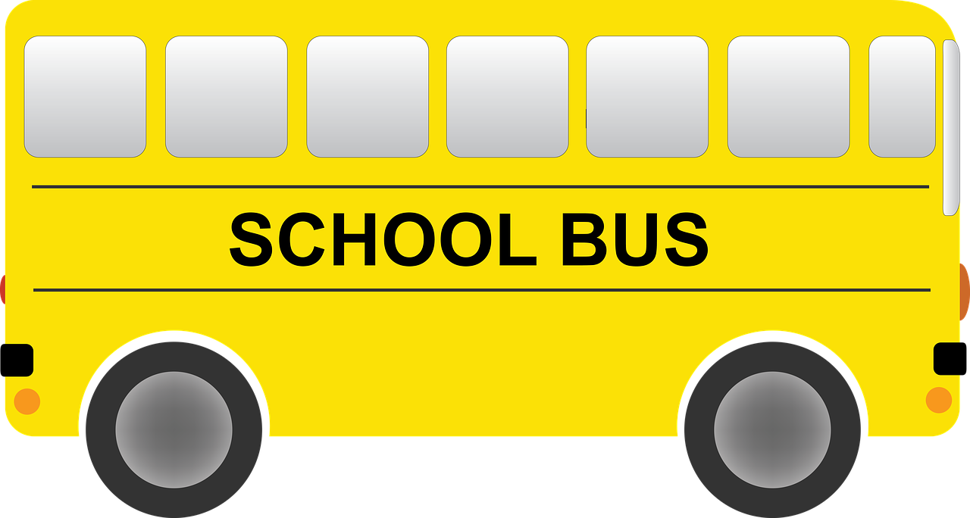

Dear Parent(s),

Welcome back! It’s that time of the year again! We are off to another exciting year of learning. I am ecstatic to have your child as a student in my classroom this year. This year has come with many unexpected surprises, but one thing that hasn’t changed is that here at Highlands, we strive for excellence in order to obtain success. I am looking forward to working with each one of my students whether in person or remotely. This year will be challenging however, I will do my best to make their learning experience interesting and enjoyable. The activities planned will help to develop the academic, social, and creative skills of each student.

I believe parent involvement is essential in the learning process. I do ask that as I work with your child that YOU also become a major influence in their learning as well. Please be mindful of the expectations given by the district, our principal and myself. I believe communication is very important. You are invited to email or call me at any time to enquire about your child's progress and academic success. In addition, it is important that you and your child be informed of my standards of classroom behavior so everyone knows what is expected. I have always found that parents that are supportive of good classroom behavior help to foster responsibility in their child’s academic growth. This awareness allows the child to obtain a good environment for maximum learning. I have attached my discipline plans for my classroom. Please review and discuss the expectations with your child.

In addition, please review and sign the student handbook by September 4, 2020! On September 22, 2020, all parents are encouraged to attend the Meet the Teacher Night. This year we will be conducting our Meet the Teacher Night virtually. There we will discuss in depth the curriculum, standards, rituals and routines, and expectations for this school year.

Again, I consider it a great privilege and responsibility to be your child's teacher this year, and I look forward to a wonderful school year!

Sincerely,

Mrs. Haskin-Goshay

[nhaskin@phsd144.net](mailto:nhaskin@phsd144.net) or [nhaskin@phesd144.com](mailto:nhaskin@phesd144.com)

**Ms. Goshay’s Discipline Plan**

**Classroom Rules**

1. Keep hands, feet, and all objects to yourself.
2. Raise your hand and wait before speaking.
3. Raise your hand and wait before leaving your seat.
4. Be respectful, responsible, and safe at all times
5. Follow directions the first time given.

**Safety Rules**

1. All students MUST be self-certified by their parents before arriving at school.
2. All students are required to wear a mask when entering into the school building, throughout the school day, as well as when riding the school bus.
3. Students are allowed to bring unopened water bottles into school, and/or empty water bottles which can be filled with water once in school.
4. Students MUST maintain a distance of 6ft in class, hallway, and cafeteria.
5. There is absolutely no sharing of supplies/food before, during, or after school with other classmates.
6. Students MUST wash and sanitize their hands.

**Remote Learning Rules**

1. All students participating remotely are expected to be visually present and participate during the instructional hours.
2. ***(NO CAMERAS CAN BE OFF AT ANYTIME)***
3. Students must stay muted unless prompted by the teacher.
4. All students are required to follow the District’s policy for attendance.
5. All remote students will follow the schedule for their Learning Block, specific small groups, lunch breaks, and specials.
6. All work MUST be completed and turned as assigned by the Teacher!
7. If tech support is needed while participating remotely, please visit the district’s website: [www.phsd144.net](http://www.phsd144.net/), and click on the green tab which states “Send Message.”

**Rewards and Consequences**

The students will receive rewards or consequences based upon their behaviors.

**Remote Learning Monitoring**

1. Students who are absent 10 or more consecutive days will be dropped and will have to re-register.
2. Any students not actively participating or visual in class will receive a phone call home and a notification sent to the principal.
3. Parents will be notified about any student that has not completed or turned any assignments. (Remember Grades will be issued as A, B, C, D or F)

**In person monitoring**

Behaviors are managed by a color behavior chart. Those students that consistently follow directions will receive highlands high fives or stickers to add to their behavior chart throughout the day for being respectful, responsible, and safe. If the students stay on green by the end of the day, the student will receive a sticker on their sticker chart.

If the student(s) do not follow the rules as listed above the following consequences are implemented.

Warning-Students will receive ONE warning and given a chance to change their behavior.

1. Color Change-from green to yellow-Loss of 5 minutes of free time
2. Color Change-from yellow to orange- Loss of 10 minutes free time-Parent Note
3. Color Change-from orange to red- Loss of all free time-Parent Note and Phone Call
4. Color Change: anything after red- Phone Call-Sent to office.
5. (Mandatory Parent Conference)

*Note: Students will receive an opportunity to change their colors back to the previous color depending on behavior! However, a parent note or phone call will still be sent/made.

**Individual In Person Student Rewards may include:**

1. Free game time
2. Free computer time
3. No homework Pass
4. Prizes from the treasure chest
5. High Five Store (prices vary)

**Class Rewards**

1. Whole Class Extra Recess
2. Free Time
3. Party (may vary from popcorn to pizza party)
4. Movie Day

**Remote Learning Rewards**

1. Break time
2. Appreciation Times
3. Show and Tell
4. Certificates
5. Surprise Gift from teacher